**Assignment No:-34**

Name:-Suryawanshi Sangramsingh Sambhaji

Batch: - Delta - DCA (Java) 2024 Date:-25/6/2024

**TOP STRING QUESTIONS FOR INTERVIEW AND LOGIC BUILDING.**

**Q1. Reverse the vowels only (Flipkart)**

**S = "practice"**

**Output: prectica**

**Explanation: The vowels are a, i, e**

**Reverse of these is e, i, a.**

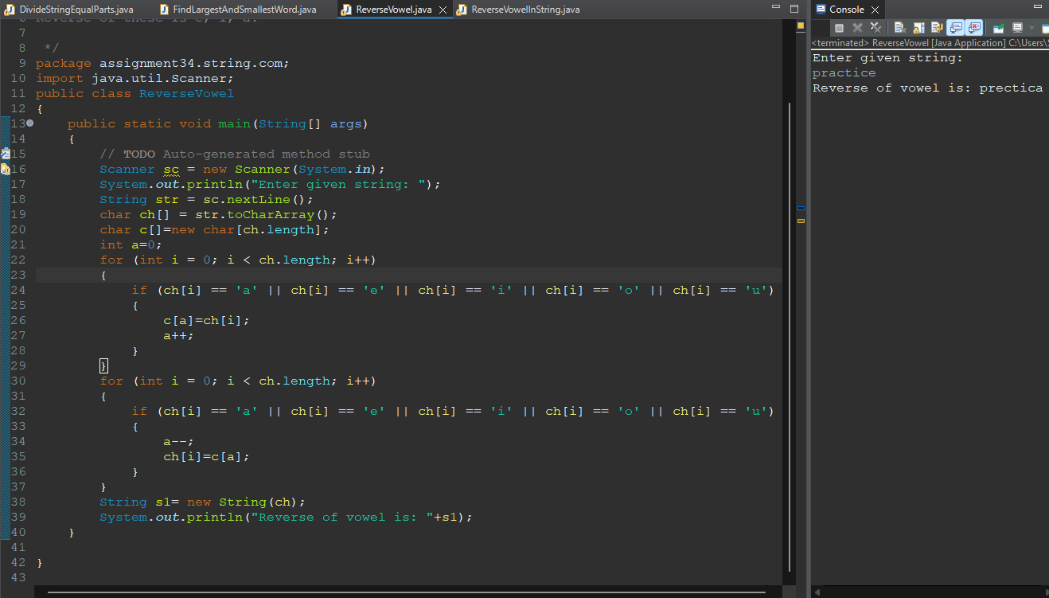

**Q2. Delete alternate characters (Amazon)**

**Input: S = "Geeks"**

**Output: "Ges"**

**Explanation: Deleted "e" at index 1**

**and "k" at index 3.**

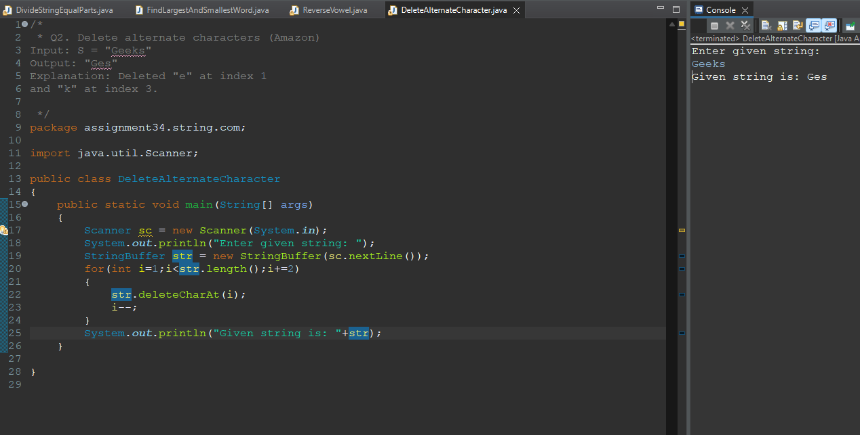

**Q3. Extract the integers (Zoho)**

**Input:**

**s = "1: Prakhar Agrawal, 2: Manish Kumar Rai,**

**3: Rishabh Gupta56"**

**Output: 1 2 3 56**

**Explanation:**

**1, 2, 3, 56 are the integers present in s.**

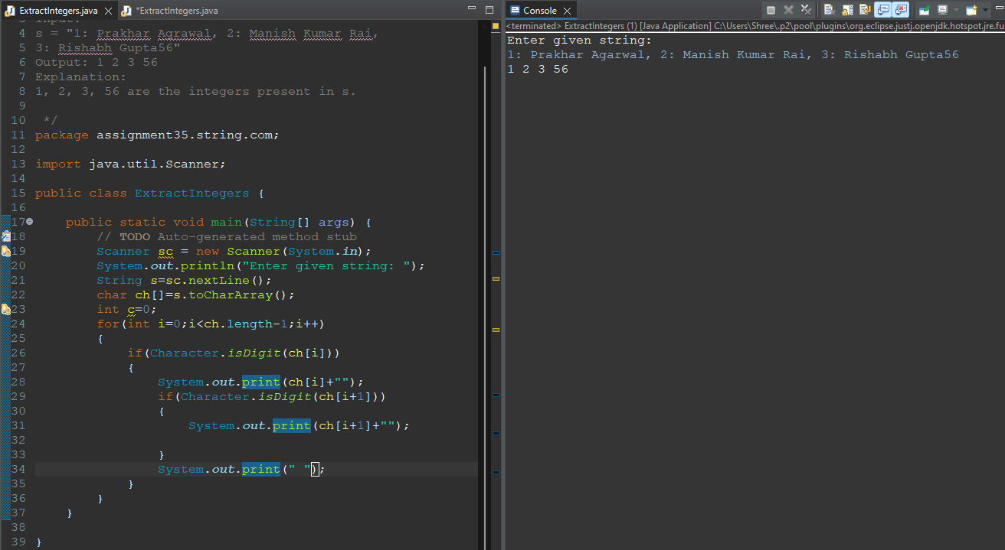

**Q4. Front-Back Transformation - copy (Microsoft)**

**Input: S = "Hello"**

**Output: Svool**

**Explanation: 'H' is the 8th letter from the**

**beginning of alphabets, which is replaced by**

**'S' which comes at 8th position in reverse order**

**of alphabets. Similarly, all other letters are**

**replaced by their respective upper or lower case**

**letters accordingly.**

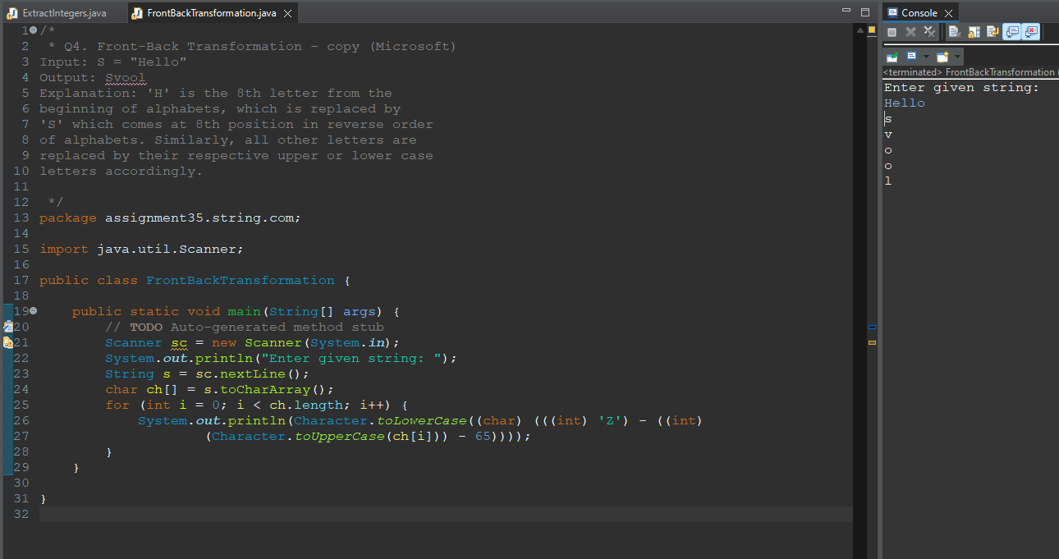

**Q5. Uncommon characters (Zoho)**

**Input:**

**A = geeksforgeeks**

**B = geeksquiz**

**Output: fioqruz**

**Explanation:**

**The characters 'f', 'i', 'o', 'q', 'r', 'u','z'**

**are either present in A or B, but not in both.**

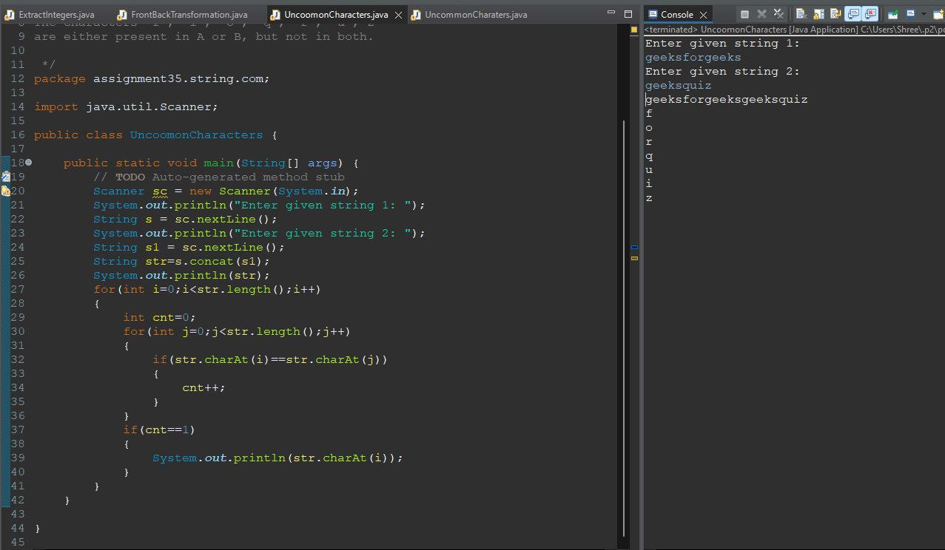

**Q6. Remove common characters and concatenate (Oracle)**

**Input:**

**s1 = aacdb**

**s2 = gafd**

**Output: cbgf**

**Explanation: The common characters of s1**

**and s2 are: a, d. The uncommon characters**

**of s1 and s2 are c, b, g and f. Thus the**

**modified string with uncommon characters**

**concatenated is cbgf.**

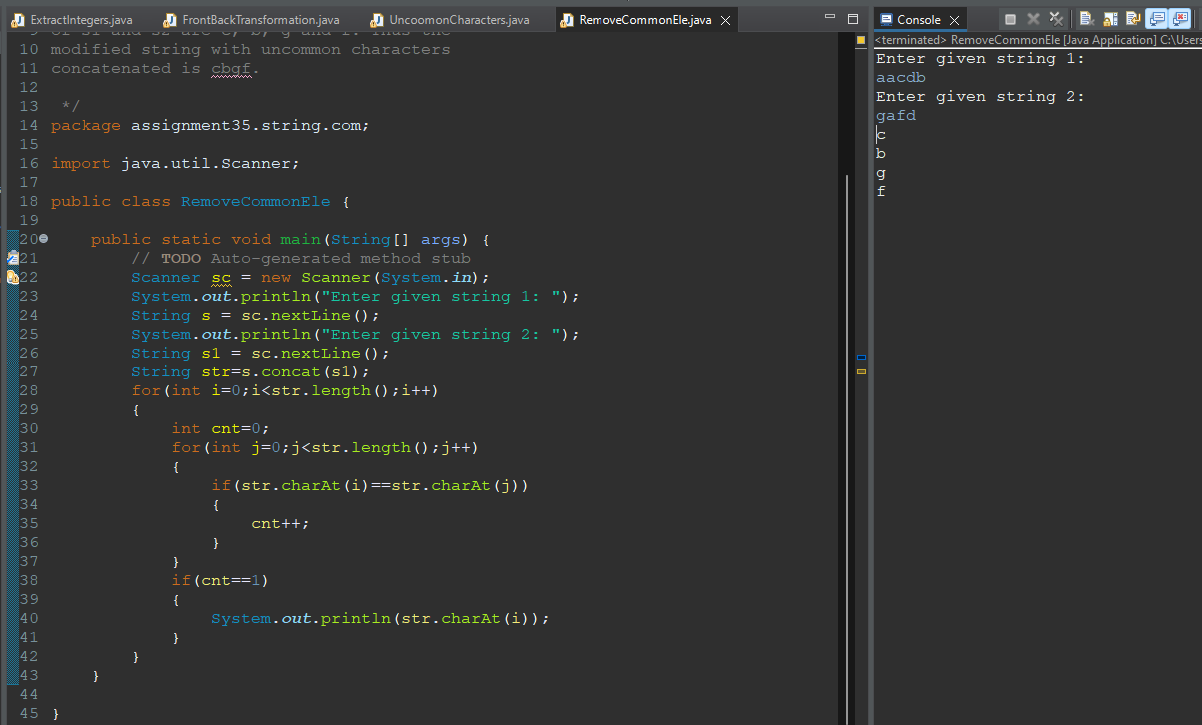

**Q7. Print first letter of every word in the string (Zoho)**

**Input:**

**S = "geeks for geeks"**

**Output: gfg**

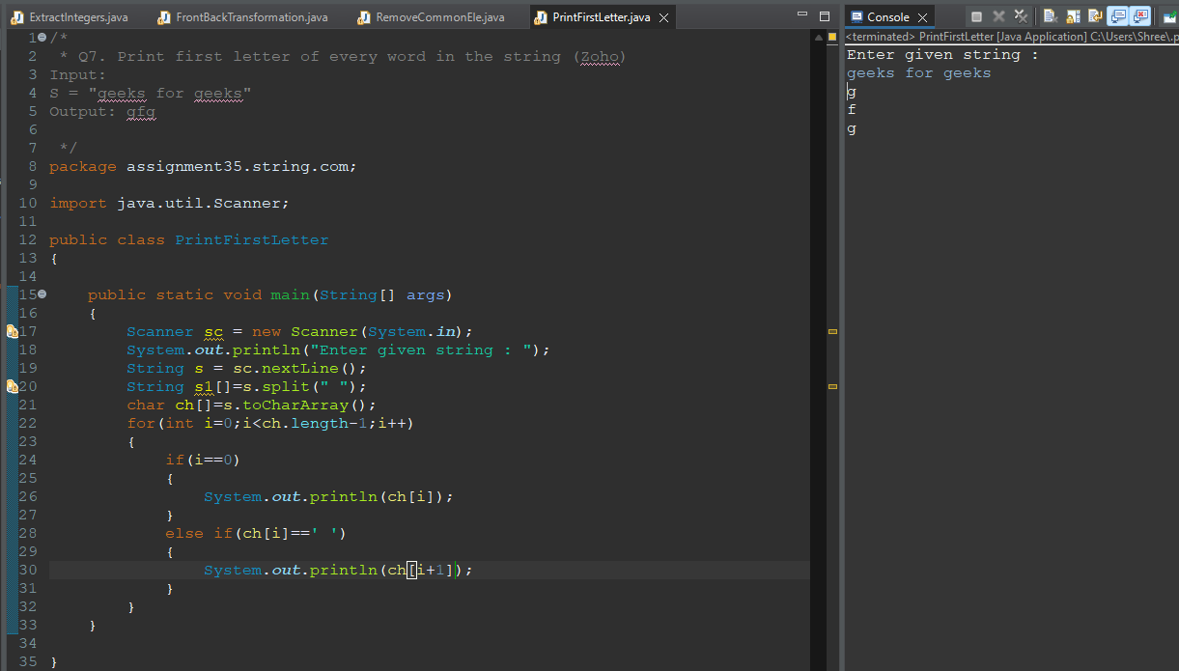

**Q8 Keypad typing (Microsoft)**

**Input: S = geeksforgeeks Output: 4335736743357**

**Explanation:geeksforgeeks is 4335736743357 in decimal when we type it using the given**

**keypad.**

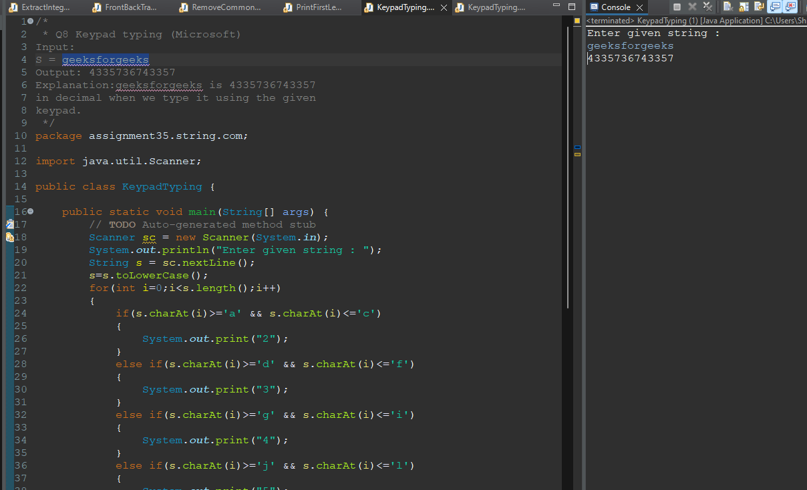 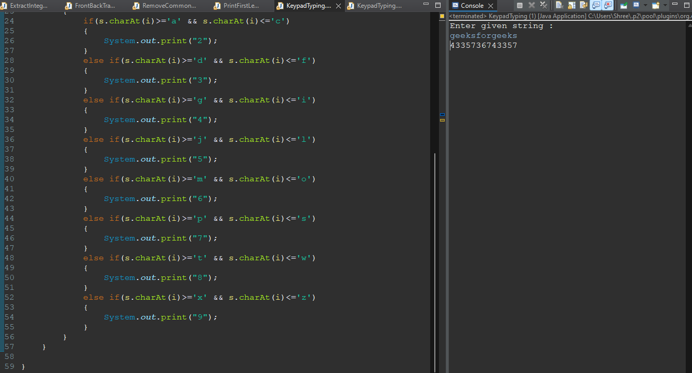

**Q9. Change the string (yahoo)**

**Input:**

**S = "abCD"**

**Output: abcd**

**Explanation: The first letter (a) is**

**lowercase. Hence, the complete string**

**is made lowercase.**

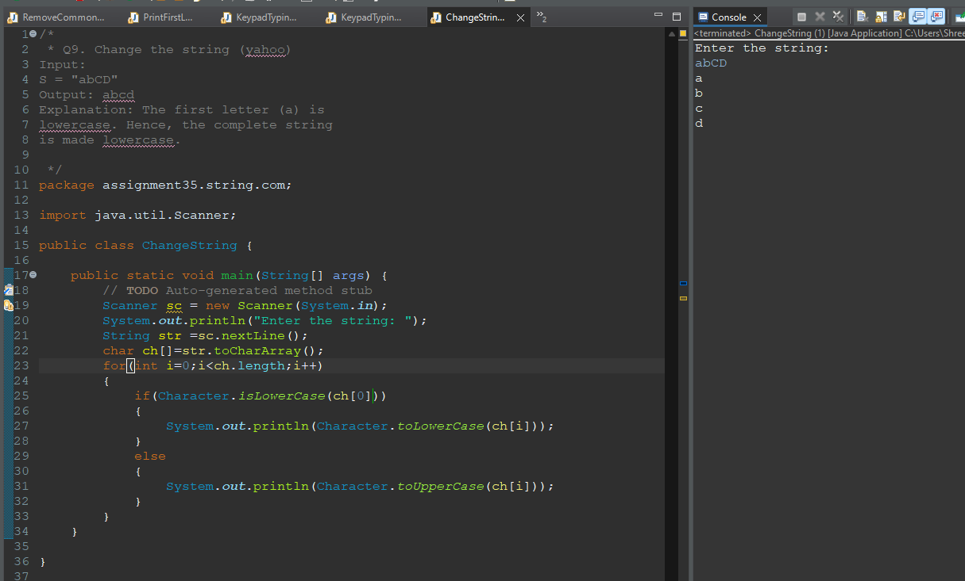

**Q10. Good or Bad string (Amazon)**

**Input:**

**S = aeioup??**

**Output:**

**1**

**Explanation: The String doesn't contain more than**

**3 consonants or more than 5 vowels together. So,**

**it's a GOOD string.**

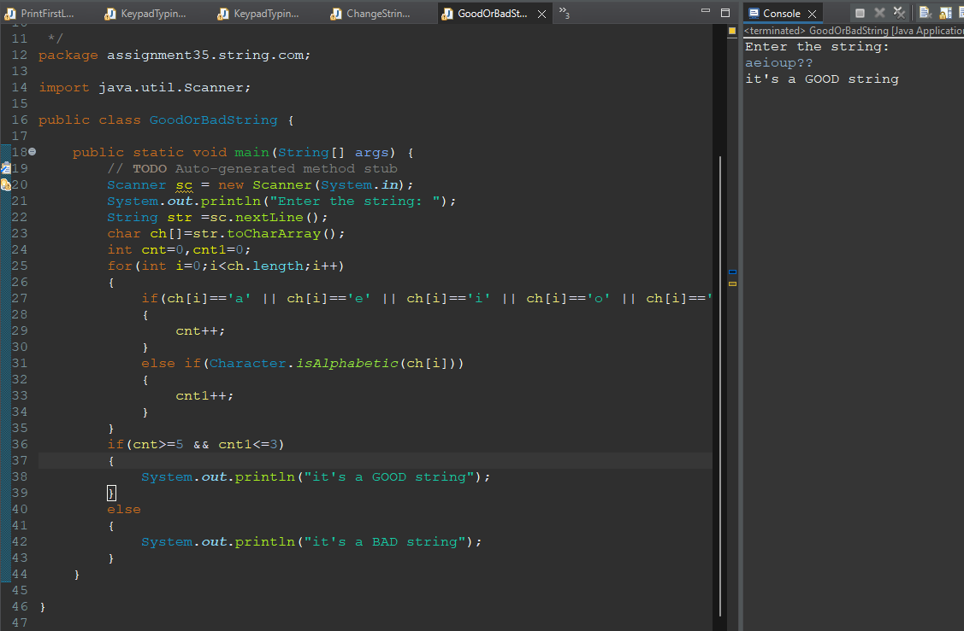

**Q11. Twice Counter**

**Input:**

**N = 3**

**list = {Geeks, For, Geeks}**

**Output: 1**

**Explanation: 'Geeks' is the only word that**

**appears twice.**

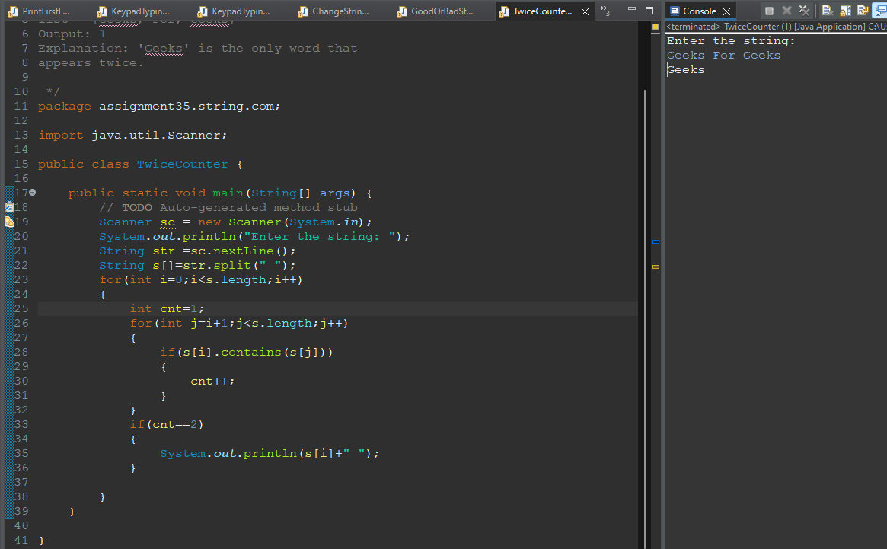

**Q12. Rearrange a string**

**Example 1:**

**Input: S = "AC2BEW3"**

**Output: "ABCEW5"**

**Explanation: 2 + 3 = 5 and we print all**

**alphabets in the lexicographical order.**

**Example 2:**

**Input: S = "ACCBA10D2EW30"**

**Output: "AABCCDEW6"**

**Explanation: 0+1+2+3 = 6 and we print**

**all alphabets in the lexicographical order.**

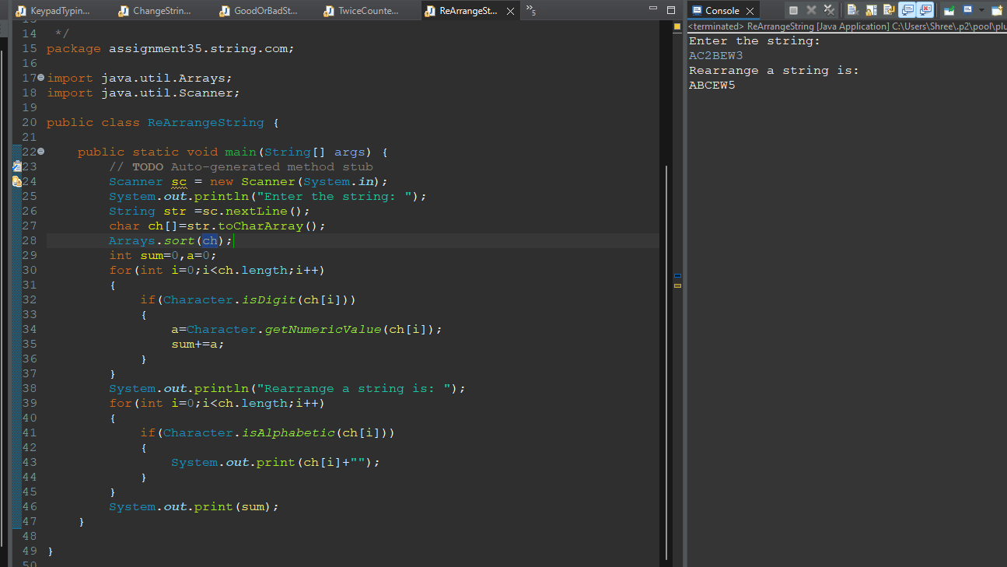

**Q13. Easy string (google)**

**Example 1:**

**Input: S = "aaABBb"**

**Output: "3a3b"**

**Explanation: As 'a' appears 3 times**

**consecutively and 'b' also 3 times,**

**and 'b' and 'B' considered as same.**

**Example 2:**

**Input: S = "aaacca"**

**Output: "3a2c1a"**

**Explanation: As 'a' appears 3 times**

**consecutively and 'c' also 2 times,**

**and then 'a' 1 time.**

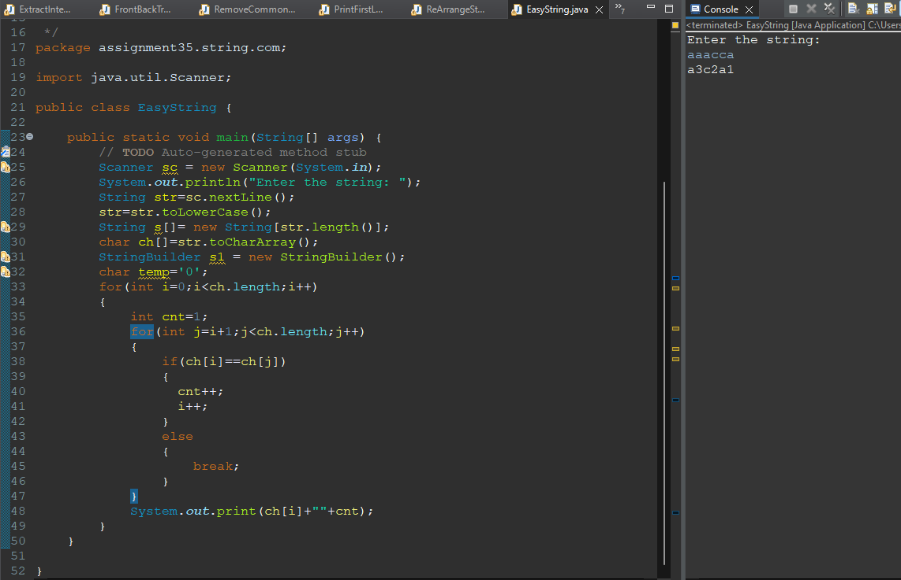

**Q14. Special array reversal (google)**

**Example 1:**

**Input: S = "A&B"**

**Output: "B&A"**

**Explanation: As we ignore '&' and**

**then reverse, so answer is "B&A".**

**Example 2:**

**Input: S = "A&x#**

**Output: "x&A#"**

**Explanation: we swap only A and x.**

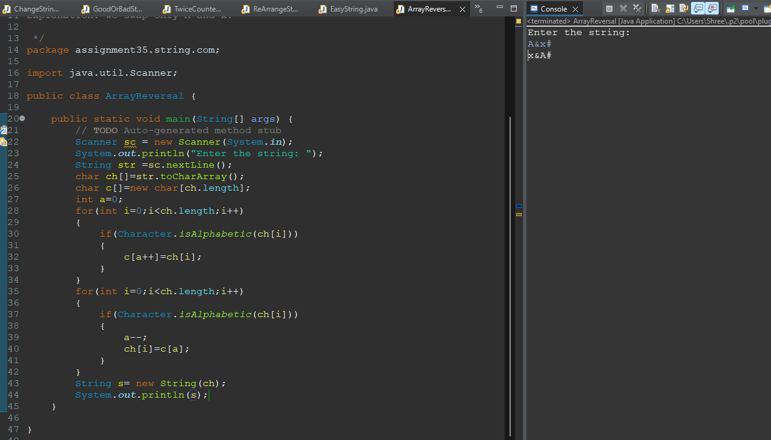

**Q15. Find largest word in dictionary (MicroSoft)**

**Example 1:**

**Input: d = {"ale", "apple", "monkey", "plea"}**

**S = "abpcplea"**

**Output: "apple"**

**Explanation: After deleting "b", "c"**

**"a" S became "apple" which is present**

**in d.**

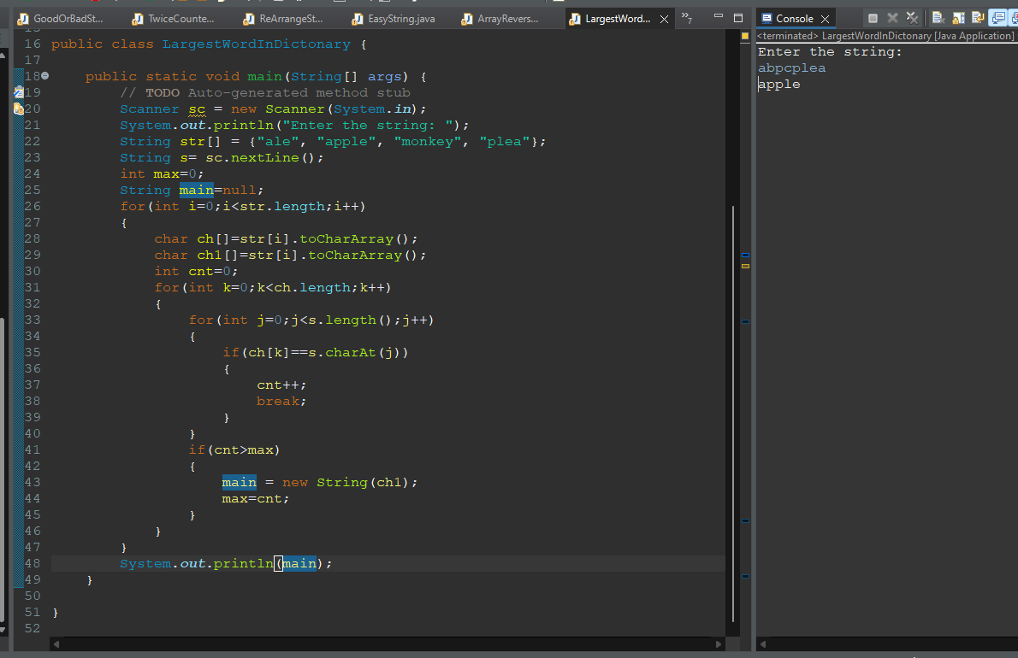

**Q16. Odd Even Problem (oracle)**

**Given a string S of lowercase english characters, find out whether the summation of X and Y is**

**even or odd, where X is the count of characters which occupy even positions in english**

**alphabets and have positive even frequency, and Y is the count of characters which occupy odd**

**positions in english alphabets and have positive odd frequency.**

**Note: Positive means greater than zero.**

**Example 1:**

**Input: S = "abbbcc"**

**Output: "ODD"**

**Explanation: X = 0 and Y = 1 so (X + Y) is**

**ODD. 'a' occupies 1st place(odd) in english**

**alphabets and its frequency is odd(1), 'b'**

**occupies 2nd place(even) but its frequency**

**is odd(3) so it doesn't get counted and 'c'**

**occupies 3rd place(odd) but its frequency**

**is even(2) so it also doesn't get counted.**

**Example 2:**

**Input: S = "nobitaa"**

**Output: "EVEN"**

**Explanation: X = 0 and Y = 2 so (X + Y) is**

**EVEN.**

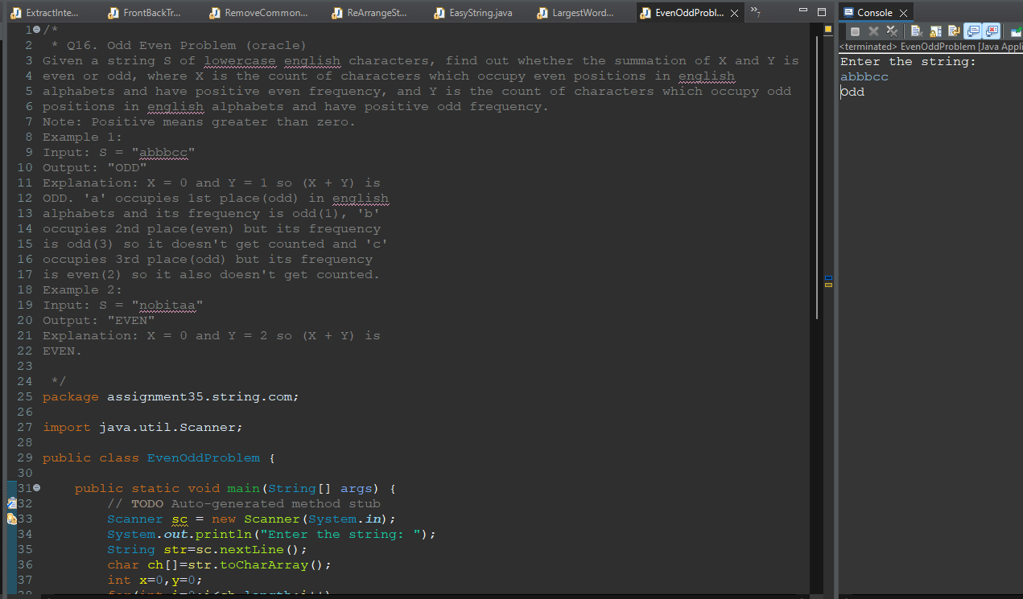

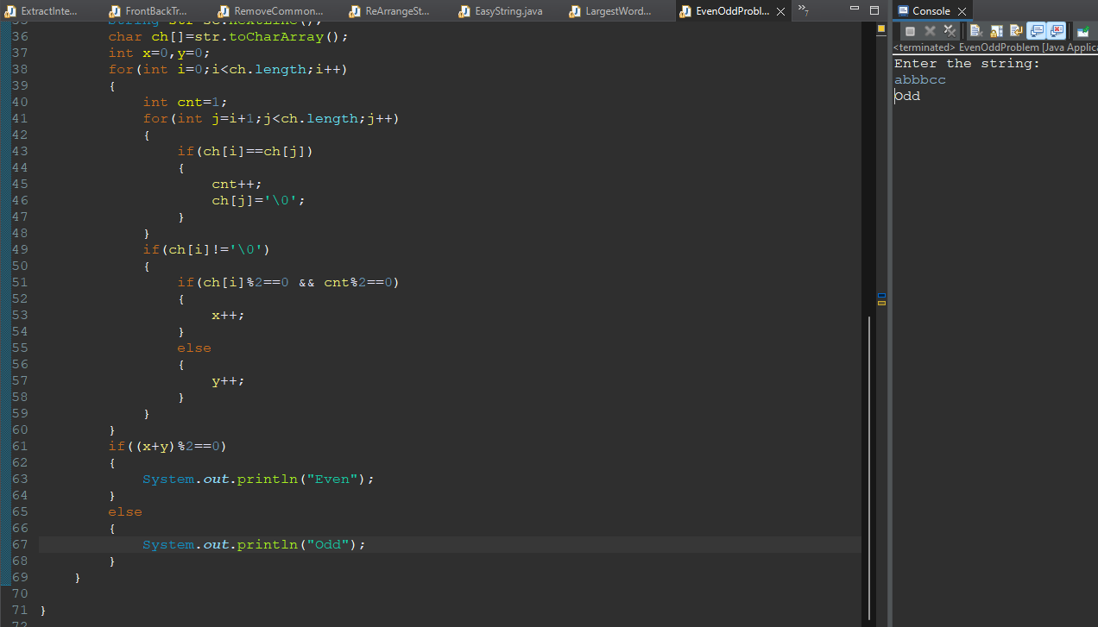

**Q17. Replace a word**

**Example 1:Input: S = "xxforxx xx for xx" ,oldW = "xx" ,ewW = "Geeks"**

**Output: "geeksforgeeks geeks for geeks"**

**Explanation: Replacing each "xx" with" Geeks" in S.**

**Example 2:**

**Input:**

**S = "india is the xx country"**

**oldW = "xx"**

**newW = "best"**

**Output:**

**"india is the best country"**

**Explanation:**

**Replacing each "xx" with**

**"best" in S.**

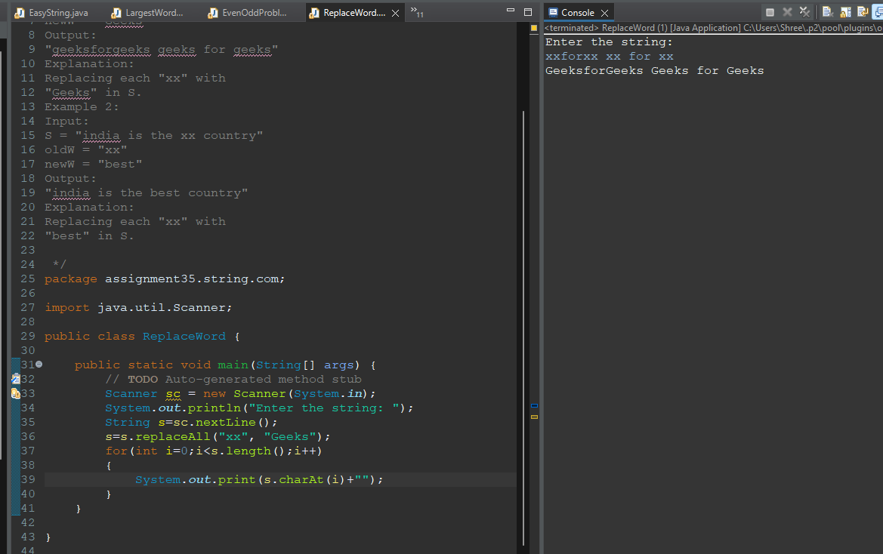

**Q18. Ordering of strings (walmart)**

**You will be given N number of strings. You have to find the lexicographically smallest string and**

**the lexicographically largest string among these strings.**

**Example 1:**

**Input:**

**N = 3**

**strings = a , ab , abc**

**Output: a abc**

**Explanation: Lexicographically smallest is**

**"a" and lexicographically largest is**

**"abc".**

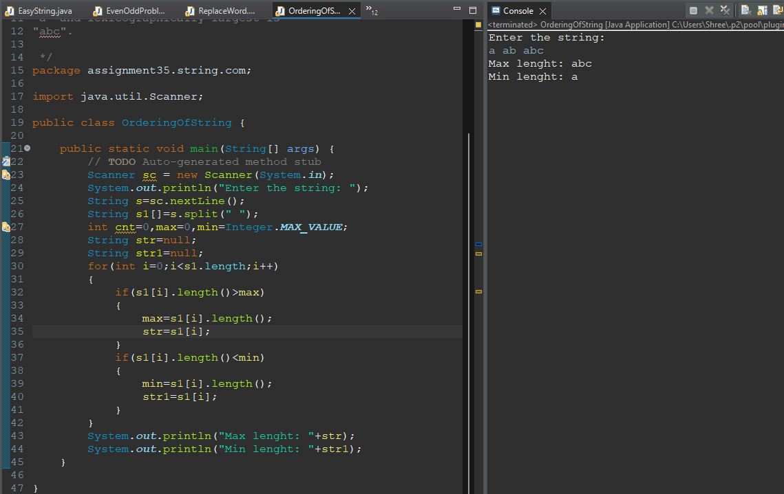

**Q19. Same characters in two strings**

**Given two strings A and B of equal length, find how many times the corresponding position in**

**the two strings hold exactly the same character. The comparison should not be case sensitive.**

**Example 1:**

**Input:**

**A = choice**

**B = chancE**

**Output: 4**

**Explanation: characters at position 0, 1, 4 and 5**

**are the same in the two strings A and B.**

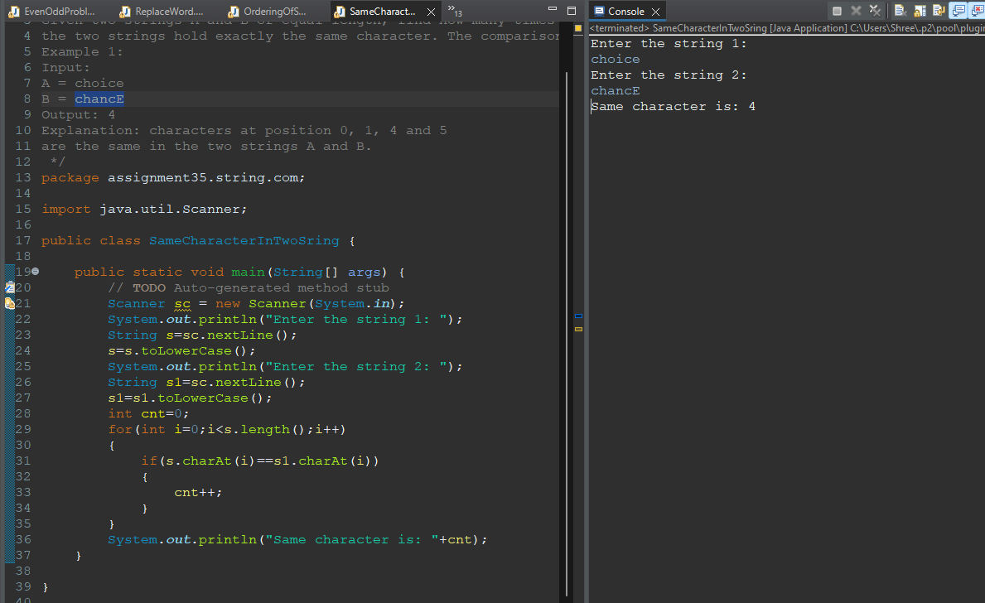

**Q20. Maximum number of characters between any two same character**

**Given a string containing lower and uppercase alphabets, the task is to find the maximum**

**number of characters between any two same characters in the string.**

**Example 1:**

**Input:**

**S = "socks"**

**Output: 3**

**Explanation: There are 3 characters between**

**the two occurrences of 's'.**

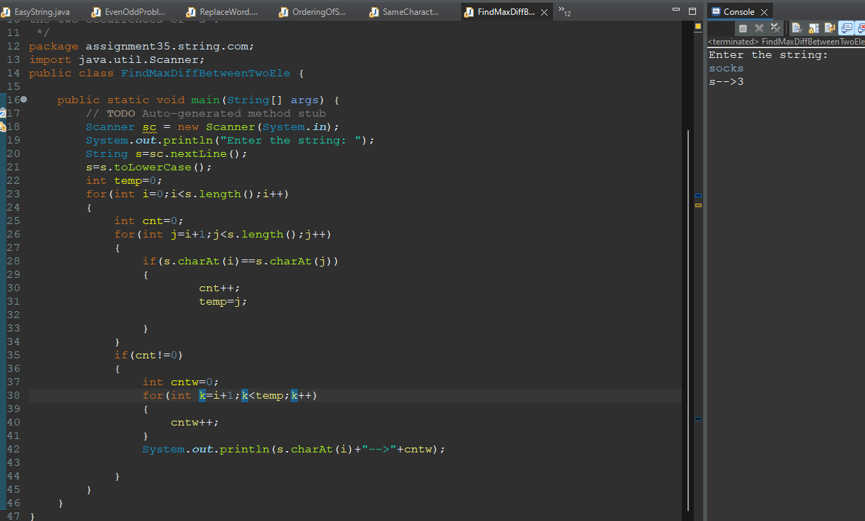

**Q21. Last Match**

**Given two strings A and B, you need to find the last occurrence ( 1 based indexing) of string B in**

**string A.**

**Example 1:**

**Input:**

**A = abcdefghijklghifghsd**

**B = ghi**

**Output:**

**13**

**Explanation:**

**ghi occurs at position 13 for the**

**last time in string A.**

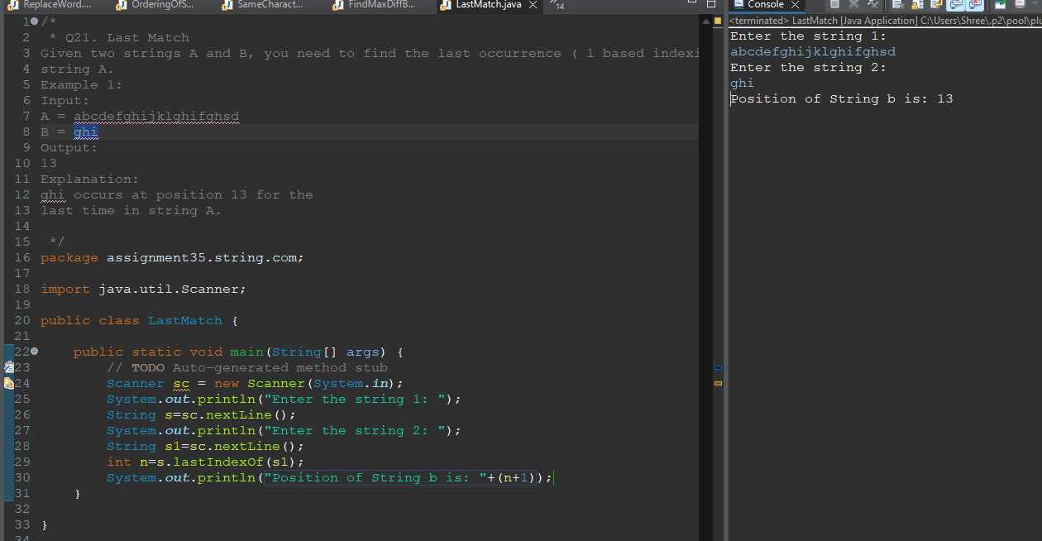

**Q22. Difficulty of sentence**

**Given a sentence as a string S. Calculate difficulty of a given sentence.**

**Difficulty of sentence is defined as 5*(number of hard words) + 3*(number of easy words). A**

**word in the given string is considered hard if it has 4 consecutive consonants or the number of**

**consonants is more than the number of vowels. Else the word is easy.**

**Note: uppercase and lowercase characters are the same.**

**Example**

**Input: S = "Difficulty of sentence"**

**Output: 13**

**Explanation: 2 hard words + 1 easy word**

**Example**

**Input: S = "I am good"**

**Output: 9**

**Explanation: 3 easy word**

